POP menu creation By AlanH, April 2026

This document is about making a POP menu with the emphasis on selecting an option via an image rather that a textural answer. The image can be used to insert a Block or call a Lisp program. IOt has been tesed on Autocad and Bricscad.
The same principle can be used to make a RIBBON menu, but the CUI editor must be used for a Ribbon. POP menu can be made used Notepad more about using Word later.
This is an example of the default DCL that is built into the CAD software, it has as a default 20 images with text labels, it supports next and previous automatically when you have more than 20 images.
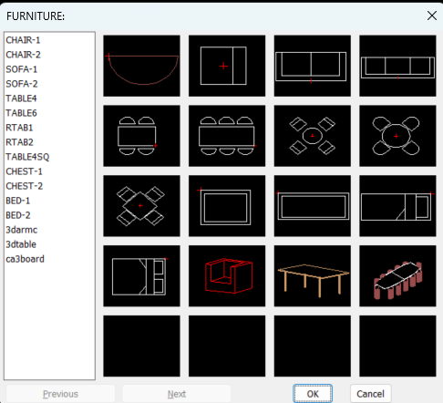

The use of custom DCL’s to make choices will be the subject of a separate tutorial.

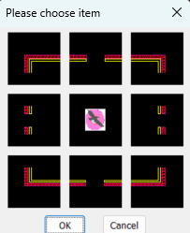

A POP menu can have sub menu’s as shown by the little > arrow.
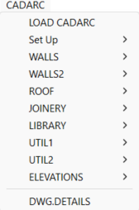

This tutorial will look at making a menu with two choices, a block insert menu and a Notes insert menu.

A POP menu has sections we are interested in Main body and Images and again they can call sub menu’s within those sections.
Make Slide images.

The first step to making images for the menu is to make a slide image, these are used as the display image. A bit of history is that SLD images were created basically when Autocad was created so they have continued to be used even today.

Ok how to make a Slide image they are saved as SLD files, its easy you just use the Mslide command. It will ask for an output slide name and location where to save the sld file.
As the slides were introduced when screen resolution was say 640x480, with modern screen resolution say 1920x1280 using the screen at full size will create an unusable slide, but its easy to get around, you just resize your CAD window down to about a ¼ size.
You just do a “zoom extents” then a “zoom0.9xp”, this fits your current object/s to a nice size in your screen.

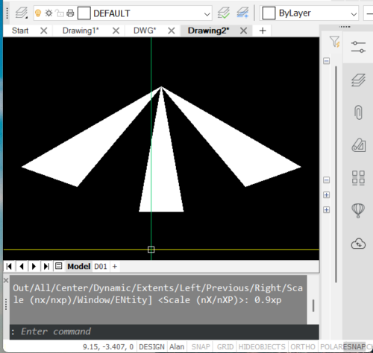
Then a simple MSLIDE. Enter the directory to save in and a Name. Ok some suggestions, all my slides I saved in a single directory, eg d:\alan\slides.
Ok we end up with lots of slides but there is a Slide library tool this allows you take multiple slide and put them into a single library file, You can have multiple SLB files which contain common group slide images, more later about using Slide manager
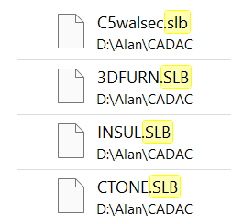

Using a text editor for POP mnu file

As suggested a two option POP menu as a starting point.

***MENUGROUP=MYPOPMENU

***POP10
**CADLIB
[LIBRARY]
[->Stddwgs]
[Images]$I=BLOCKS$I=*
[PIPES]$I=NOTES $I=*
[<-]
A quick explanation of what we have.
Please note the “***” where shown are required.
MENUGROUP=MYPOPMENU the MYPOPMENU is the name of this menu
***POP10 is the position of the POP menu as seen at top of screen.
**CADLIB is the 1st section name in the main part of the POP menu.
[LIBRARY] is the 1st heading
[->Stddwgs] the -> implies we are opening a sub menu of the shown name
[Images]$I=BLOCKS$I=* open a sub image section of the menu named BLOCKS
[PIPES]$I=NOTES $I=* open a sub image section of the menu named Notes

[<-]

Ok so now add a IMAGE section
***MENUGROUP=MYPOPMENU

***POP10
**CADLIB
[LIBRARY]
[->Stddwgs]
[BLOCKS]$I=BLOCKS $I=*
[<-NOTES]$I=NOTES $I=*

***image
**BLOCKS
[BLOCKS]
[BLOCK1,BLOCK1]^C^C-INSERT D:\alanh\blocks\BLOCK1 DRAG \1 1 0
BLOCK2,BLOCK2]^C^C-INSERT D:\alanh\blocks\BLOCK2 DRAG \1 1 0
BLOCK3,BLOCK3]^C^C-INSERT D:\alanh\blocks\BLOCK3 DRAG \1 1 0

***image
**NOTESS
[NOTES]
[NOTES1,NOTES1]^C^C-INSERT D:\alanh\blocks\Notes1 DRAG \1 1 0
[NOTES2,NOTES2]^C^C-INSERT D:\alanh\blocks\Notes1 DRAG \1 1 0
[NOTES3,NOTES3]^C^C-INSERT D:\alanh\blocks\Notes3 DRAG \1 1 0

So lets try it out. Whilst this tutorial is written in MS Word if you save from a Word document it saves hidden information so it is best to always use a plain text editor when making MNU files, Notepad and Notepad ++ are good text editor for this task.
So Copy the example here and paste into a blank notepad file, save as say Mypopmenu.mnu.

In CAD just type “Menuload” then choose the saved “Mypopmenu.mnu”
So you should see this after clicking on “LIBRARY”


Ok so why is it not working when we select say BLOCK1 ? We need to have carried out step 1 and made slides called “BLOCK1” “BLOCK2” etc. We also need to tell the CAD software where to find the slides and blocks, this is simple to do.
Just type “OPTIONS” on command line select “FILE” then “Support path” add the two paths to the support path list and save Options, you can add the full path but it is much easier to use a support path.
Edit the menu file t o have correct saved sld file names and block names. Use Menuunload to remove the menu and Menuload to load the new menu. Your new menu should work.

Adding more options to the pop menu.

So we have a POP menu now so why not add some lisp programs. Its just a case of adding to our menu. We don’t need images for the lisp programs, but could do if you want, rather we will use description to load the lisp.

***MENUGROUP=MYPOPMENU

***POP20
**CADLIB
[LIBRARY]
[->Stddwgs]
[BLOCKS]$I=BLOCKS $I=*
[<-NOTES]$I=NOTES $I=*
[--]
[->LISPS]
[LISP1]^C^C(load “lisp1”)
[LISP2]^C^C(load “lisp2”)
[<-LISP2]^C^C(load “lisp3”)

***image
**BLOCKS
[BLOCKS]
[BLOCK1,BLOCK1]^C^C-INSERT D:\alanh\blocks\block1 DRAG \1 1 0
[BLOCK2,BLOCK2]^C^C-INSERT D:\alanh\blocks\block2 DRAG \1 1 0
[BLOCK3,BLOCK3]^C^C-INSERT D:\alanh\blocks\block3 DRAG \1 1 0

***image
**NOTES
[NOTES]
[NOTES1,NOTES1]^C^C-INSERT D:\alanh\blocks\Notes1 DRAG \1 1 0
[NOTES2,NOTES2]^C^C-INSERT D:\alanh\blocks\Notes2 DRAG \1 1 0
[NOTES3,NOTES3]^C^C-INSERT D:\alanh\blocks\Notes3 DRAG \1 1 0
Again we have used the saved support path for the LISP files. We could have put a full path, ^C^C(load “D:\Alanh\lisps\lisp1”)

You should see
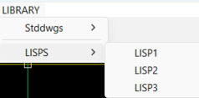

So again replace ‘LISP1” with a correct lisp program name.
If your lisp loads and expects you to type a command to run then just edit the lisp menu line.
[LISP1]^C^C(load “lisp1”) mylispcommand
Note the single space this is the same as pressing enter after loading the lisp.

Now for some good news, there is some helpers, you can use lisp to make slides, lets take the task of blocks to slides, basically just need a list of the block names. You can display on screen the names of the blocks in a dwg wether visible or not. If only a few display to screen and copy and paste to say notepad. You can write direct to a files as well.

The second part is again taking a list of say your slide names you can use a text editor and search and replace to write the partial mnu file for you or use a lisp to write the mnu file my preference. It just saves a lot of typing and possible errors.

Lets look at make a list of all block names in a dwg. Once you have this you can remove any block names you don’t want as slides.
Lisp Blocks to list
Just copy this to notepad and save. Use Appload or drag and drop from Explorer and lisp will auto run.

((defun blk2lst ( / filelst blks blk)
(setq blst '())
(setq filelst (open "D:\\Acadtemp\\sldlst.txt" "W")) ; change directory and filename as needed.
(setq blks (vla-get-blocks (vla-get-activedocument (vlax-get-acad-object) )))
(vlax-for blk blks
(setq bname (vlax-get blk 'name))
(if (or (= bname "*Paper_Space")(= bname "*Model_Space"))
(princ)
(setq blst (cons (vlax-get blk 'name) blst))
)
)
(setq blst (acad_strlsort blst))
(foreach blk blst
(write-line blk filelst)
)
(close filelst)
(princ)
)
(blk2lst)

Read a file of block names and make slides.
Make slides from a list of blocks.

Again set the directory to where you want to save the slides.
(defun mkslides ( / fname bname)
(alert "Have you set the screen to correct size ? \n\nIf not press ESC now ")
(setq fname (open "D:\\Acadtemp\\sldlst.txt" "R"))
(setvar attreq 0)
(while (setq Bname (read-line fname))
(command "-insert" bname "0,0" 1 1 0)
(command "zoom" "Extents")
(command "Zoom" "0.9XP")
(command "mslide" (strcat "D:\\Acadtemp\\" bname))
)
(command "Erase" "Last" "")
(princ)
)
(mkslides)

You should have enough information now to make a POP menu replacing the sld and block names in the example code above.

Part two is how write POP menus using lisp, a separate tutorial.

