Within BricsCAD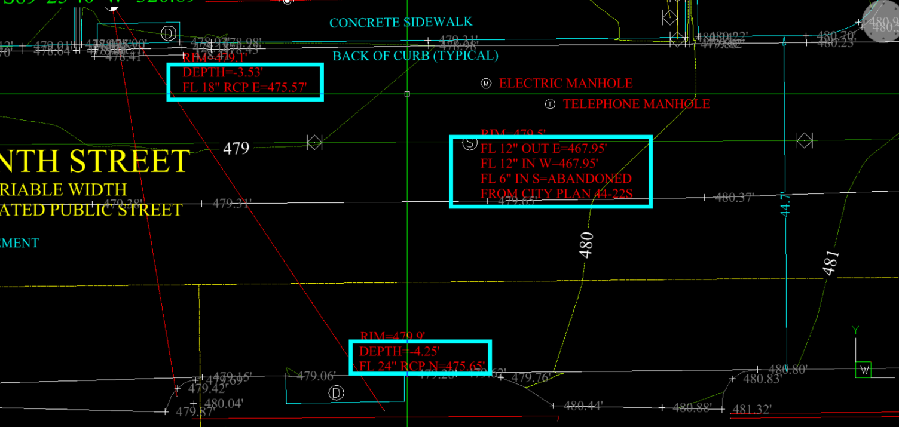

Within Civil 3D 2017 / AutoCAD 2015 (has been confirmed doesn’t not show)
