

AlanH Consulting LISP programs June 2023

General instructions

To use the programs just save them to a directory that is included in your Autocad search path.

If you need more information how to do this see "Saving AlanH Consulting lisp files.doc".

These lisp programs are accessed via the following methods from within AutoCAD.

The majority of programs that you will use often have been set-up to load automatically from a menu or toolbar and run on 1st load, some can be ran again you need only type a short key sequence to re-use eg "XP"

AlanH Consulting can help making a menu, toolbar or ribbon to run the programs.
Manual loading of program

Type Appload,

Followed by choosing the lisp directory, where all the files are saved
Pick the required program,
Pick "Load" then "Close"

How to use

Some programs start straight away and you just follow the prompts or fill in user values. Others will give you a message on the required keyboard entry so program can be repeated again without reloading.

The programs below, names are indicated as well as their shorthand keystroke if available.

Contents

Copyright© June 2023
Alan J. Houston

Contact: Sea.haven@bigpond.com

Permission to use, copy, modify, and distribute this software for any purpose and without fee is hereby granted, provided that the above copyright notice appears in all copies and that both that copyright notice and the limited warranty and restricted rights notice below appear in all supporting documentation.

The following program(s) are provided "as is" and with all faults.
Alan J. Houston DOES NOT warrant that the operation of the program(s) will be uninterrupted and/or error free. The author assumes you are an experienced Autocad, Briscad and Autolisp user and or programmer. AlanH Consulting can provide additional help and customisation but this service may require payment.

You may copy, modify, and distribute this code for your own use or company use. You may not copy any portion of this code for the use in other codes for resale or sell this code

Not responsible for errors due to changes with or without notice.

==============================================================================

Research

Information used for these programs was also obtained from the following resources:

www.cadtutor.net
www.augi.com
Lee-mac www.lee-mac.com
www.theswamp.org
Alan J. Thompson (alanjt) Contact: alanjt @ TheSwamp.org, CADTutor.net
www.autodesk.com

Running the programs

The majority of commands can be accessed from a pull down menu

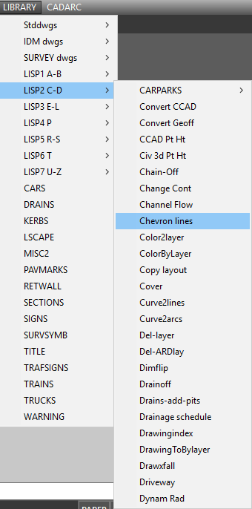

Alternatively some options can be selected from a customised toolbar

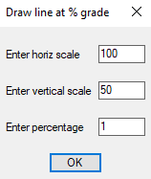
Alanh Consulting can provide this service for you.
The majority of code uses DCL dialogue input so the user’s vision is kept on the screen rather than on the command line and when possible default values are pre defined so user can use mouse to pick rather than keyboard entry.
2 Fillets
Do 2 fillets to a tee line intersection

..................................................................................................................
Allbylayer

Change non complex objects to Blayer a simple routine that prompts to select objects to be changed. Note for simple objects only.
..................................................................................................................
Add an attribute to block

Add a block attribute to an existing block with or without attributes.
..................................................................................................................
Add atts to att

Add 2 block attributes and put the value as a field into the 3rd attribute.

Add dimension values put result into mtext

Adds selected dimensions reading measurement and sums them into a new mtext.
..................................................................................................................
Add edge rectang

Adds a new rectang from existing rectang selected side with a width.
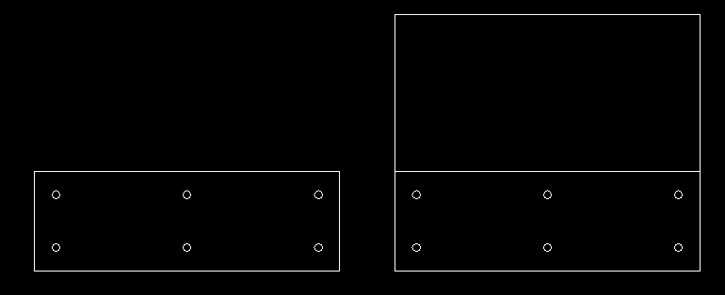
..................................................................................................................
Add holes to rectang

Select a rectang and add holes.
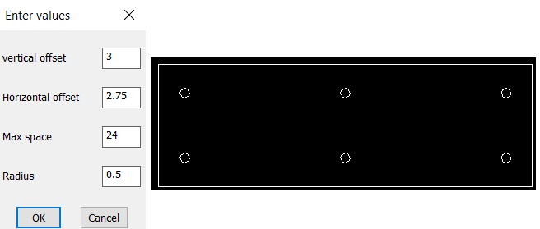
..................................................................................................................
Add layout next to existing

Copy a layout and insert new one next to it, rather than at end.
..................................................................................................................
Add to levels + Add to levels multi

Add or subtract an amount from existing text values.
Single or multiple selection of text.
..................................................................................................................
Add pits drain

Add a circle to end of lines for import into the DRAINS software.
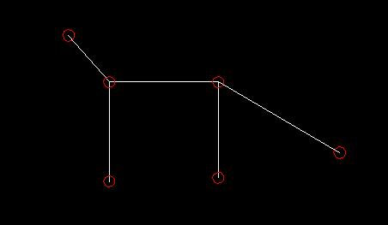
..................................................................................................................
Alan excel Library

Multiple functions for experienced lisp users to interact with Excel directly.
Examples, Open file, Get put & cells, Select range for import.
..................................................................................................................

Alignment-pline

Recreate Civ 3d Alignments as plines arcs and lines.
..................................................................................................................
Alignment label-1

Reads a Civ3D alignment and gets its properties.
..................................................................................................................
Allbylayer

A simple set objects to Bylayer.
..................................................................................................................
Append text

Adds a prefix to text.
..................................................................................................................
Arc between 2 lines

 Pick 2 lines and add an arc without erasing lines.
..................................................................................................................
Arc-to chords

Converts an arc to a equal length of chords, just enter how many chords required and pick arc's.
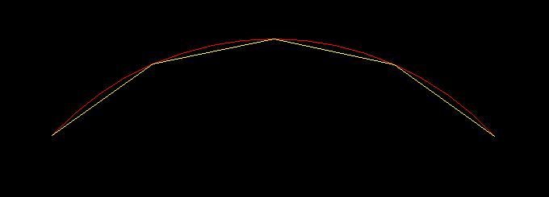
..................................................................................................................
Arc-to multi arcs

Converts an arc to an equal length of arcs, just enter how many arcs required and pick arc.
..................................................................................................................
Arc ends to line

Adds an arc to end of a line or pline.

..................................................................................................................
Att on off
Select a block attribute and turn the visibility to off.
..................................................................................................................
Att to table cell
Select a block attribute then select a cell in a table and place value as a field.
..................................................................................................................
Autocad-to-word
Advanced programming, select text and send to Word.
..................................................................................................................
Batter ticks
This inserts batter ticks between 2 plines using a predefined tick block.
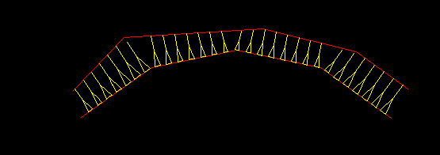
..................................................................................................................
Block count by layer
As name implies counts blocks based on a selection and counted by layer name.
..................................................................................................................

Block insert
This is a simple insert all blocks in the current drawing, just enter a spacing and maximum number of rows. the blocks are inserted in a grid pattern.
..................................................................................................................
Block-att-into table

This is a more advanced version of counting blocks, it looks at the block name and attributes, it counts down to five levels of attributes. The block can have multiple attributes but only the 1st five are used in the counts.

"Door" "Black" "Silver handle" 5,
"Door" "Black" "Gold handle" 8
..................................................................................................................
Block image into table
You can pick a block for placement of the block in a table cell.
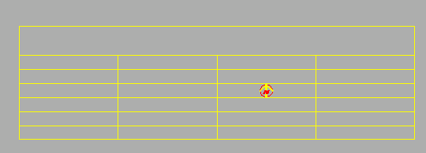
..................................................................................................................
Block insert

It is intended to be a library function and be either loaded using a simple defun or autoloaded on start up, if you have any questions please contact AlanH Consulting and we can assist. ..................................................................................................................

Block shortcut insert

This routine allows you to type "B" then block name rather than using" Insert", example b0001 will insert block "0001”

It is intended to be a library function and be either loaded using a simple defun, menu option or autoloaded on start up, if you have any questions please contact AlanH Consulting and we can assist. Once loaded can be repeated as often as required.
.................................................................................................................
Blockscale
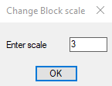
Changes the global scale of blocks, enter the new scale and select blocks to be changed.

.......................................................................,...........................................
Blockscalexyz

Changes the X Y and Z scale of blocks, enter the new scales and select blocks to be changed.
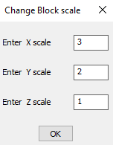

.......................................................................,...........................................
Box
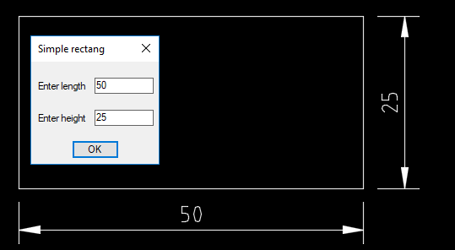
Draw a simple box and dimensions it at the same time.

..................................................................................................................
Box 4 holes dimensioned
Draws a rectang with 4 holes based on variables.
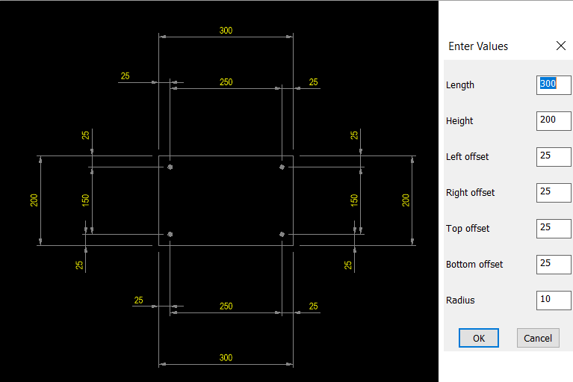
..................................................................................................................
Brg dist
Draw continuous lines by entering distance and bearing.
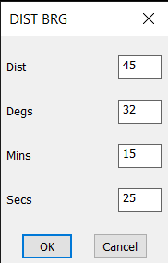
..................................................................................................................
Change hatch pat
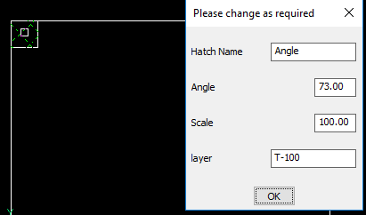
This allows you pick a hatch pattern and change the properties of it for selected occurrences, including changing the actual pattern. During selection the "All" option can be used.
Useful where you want to change one hatch parameter but for all selected hatch's.
..................................................................................................................
Carpark

This is a simple car park, line marking and allows for various angles and bay widths.

..................................................................................................................
Centroid
Simple get centroid of a closed area.
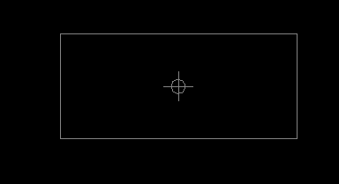
..................................................................................................................
Change 1 att all blocks

Pick 1 attribute in a block and change all blocks of same name with new matching attribute value.
..................................................................................................................
Change hatch pat-2

Similar to Change hatch pat but it changes a hatch inside a block this will reflect in all instances of that block.
..................................................................................................................
Changecontours

This allows the changing of CIV3D surfaces style from a toolbar rather than using Toolspace, a more practical way.

It has multiple parts, lisp, icons and tool bar menu.

The instructions to use are in Changecontours.zip

There is some minor user editing required of the surface style names being used by the end user, if not competent to make the changes to a menu file (text file) a screen shot of your surface styles can be sent to AlanH consulting and the changes will be made for you.
..................................................................................................................

Check text style height

A library function to check if a text style has the height preset, used in lisp code as text can be created in two ways depending on if the height is set.
..................................................................................................................
Chkbrk

Used to check a lisp program for paired brackets it writes a copy file that can be opened and shows the number of open brackets, matched code will end with 0, useful in larger coded lisps.
..................................................................................................................
Chainage on polyline
Many versions available. At fixed spacing and or pick points.
..................................................................................................................
Change att by position

Change an attribute value in all blocks of same name, using creation order rather than by attribute tag name
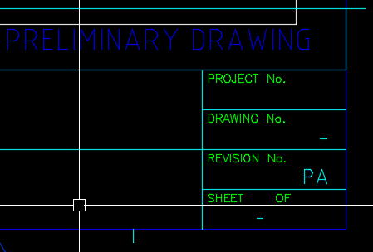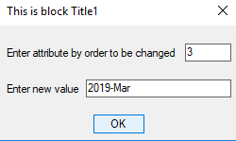
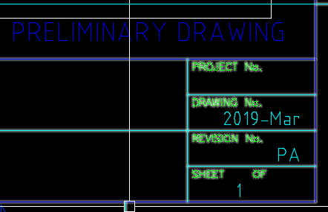

..................................................................................................................
Channel flow

This gives flows using the Mannings formular for shapes such as pipes and open channels.
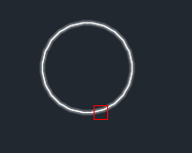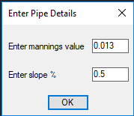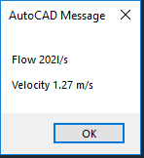

Open shapes are supported as well as box culverts.

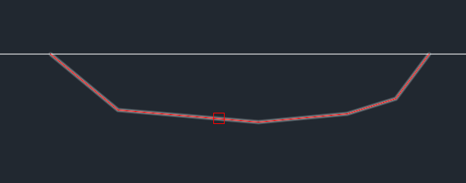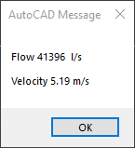
..................................................................................................................
Circle-to chords

Similar to arc to chords pick circle and enter the number of chords.

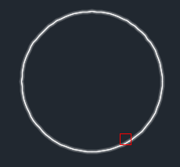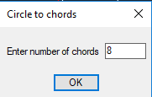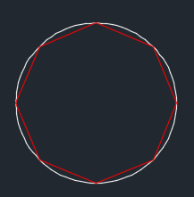

..................................................................................................................
Civ3d Change text style in labels

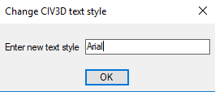
As the name implies allows the changing of the text style to be used in the CIV3D styles. Just enter the new style name required.

..................................................................................................................
Civ3D Changepointstyle

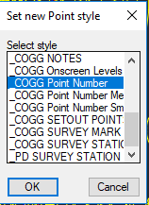
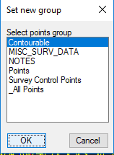
Allows the changing of the CIV3D point style using a simple dialouge list box selection rather than using toolspace.

..................................................................................................................
Civ3d create point

This is an example of adding CIV3D points via lisp
..................................................................................................................
CIV3d Import description keys

You can export description keys from CIV3D this routine allows the importation of description keys, using a csv file that can be produced quickly and simply from Excel. Please contact AlanH consulting for further details.
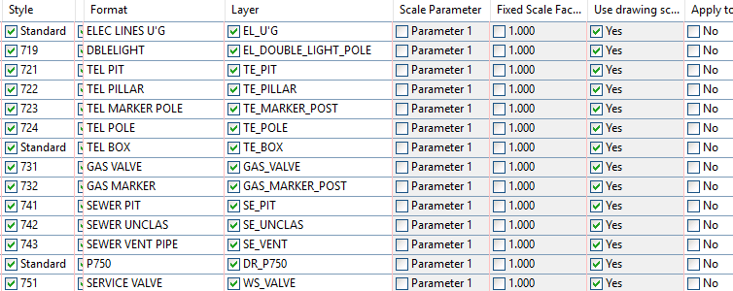
..................................................................................................................

Civ3d point edit desc

You can change a CIV3D point description via its point number to a new description.

..................................................................................................................
Civ3d pt ht
Allows you to label a Civ3d point Z value as text, picking as many as required.
..................................................................................................................
Civ3d rotate point

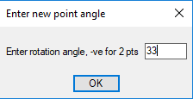
Allows the user to rotate a CIV3D point by nominating an angle or picking two points for the angle, just enter a negative value for pick two points.

..................................................................................................................
Contours to rl

This is useful to convert 2d contours or lines that are on a layer that represents an elevation eg layer name 86. will move objects to elevation 86.0
..................................................................................................................
Cogo point as text

Pick a CIV3D Cogo point and write text with X Y Z .
..................................................................................................................
Copy layout to another

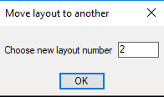
This allows you to copy a layout to another layout it moves the objects on the destination layout 1st, This is useful where 3rd party or custom routines create a layout, moving the content as an updated version to an existing layout avoiding a lot of editing.

..................................................................................................................
Copy block atts down

You can copy an existing block with attributes up or down a set distance, it attempts to increases the value of the 1st attribute, this would be useful for title block revisions. Entering a zero for shift will allow selection of two points for the move distance.

Contact AlanH cosulting for more details.
..................................................................................................................
Copy atts block1 to block2

You can copy an existing block with attributes to a similar block with attributes .

..................................................................................................................
ColorByLayer

Converts selected objects colour to be Bylayer
..................................................................................................................
Circle end 2 lines
This creates a circle on the end of two lines and trims or extends the lines as required.
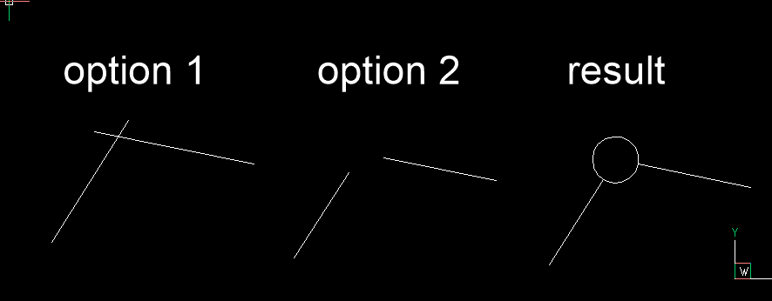
..................................................................................................................
Civilcad convert
This takes the created dwg file from Civilcad or Magnet and carries out the following steps.

Objects to Bylayer

Adds EX_ to all layer names to represent clearer that data is field survey

Removes point cross blocks but adds Autocad point as 3D point

Changes some Civilcad linetypes to Autocad line types, then removes the linetypes removing the link to the Civilcad shx that was produced. It is recommended to remove the Civilcad DOT linetype.
..................................................................................................................
Draw driveway
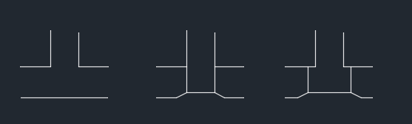
It draws a layback into a kerb you pick left and right points and accept or enter a new width.

...........................................................................................................
dd3x3
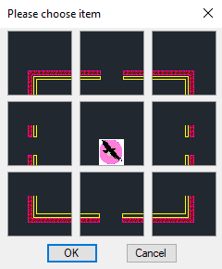
This is an example of how to create a selection dialouge a 3x3 images using Autocad slide images, there is also dd2x2, dd2x3, dd4x4 DCL source.

..................................................................................................................
Drawxfall
Allows the user to draw lines etc on an entered slope % See Draw1in also.

Just enter horizontal and vertical scale then % slope required use ortho on to draw square lines at this angle, when finished type "SNAPANG 0"

..................................................................................................................
..................................................................................................................
Draw a point by grade
to be done
..................................................................................................................
Draw Objects XlBricscad & Autocad
Using an Excel macro example to draw objects in Autocad or Bricscad, 2 versions

..................................................................................................................
Draw rectang curved sides
As per image.


..................................................................................................................
Draw X in rectangs

As name implies pick a rectang and a X is added on the diagonals.

..................................................................................................................
Dumpit

Allows a list of all properties of an Autocad object. Used by programmers.
..................................................................................................................
Dump cogo points by group

Used with CIV3D to make a list XYZ of points by group name.
..................................................................................................................

Dynamic block get put

Mutiple dynamic block update methods set properties such as visibility and variable via a dcl interface. Export properties.
..................................................................................................................
Ellispe formula

Makes an ellipse based on X & Y values and draws as line segments useful for CNC cutting.
..................................................................................................................

Feet to decimal
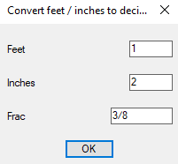

It is possible to pass the answer as a command line input using transparent command option. Need pics

Use this line if conversion is required on the fly type 'fdec when asked for input.
..................................................................................................................
Feet to decimal2
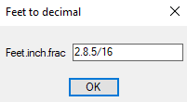
This is a single line version

It is possible to pass the answer as a command line input using transparent command option
Use this line if conversion is required on the fly type 'fdec when asked for input.
..................................................................................................................
Fillet 3 lines
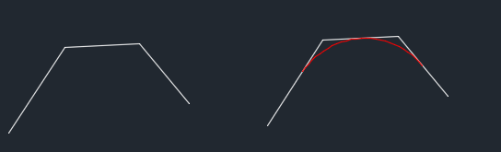
This fits a radius to 3 lines using the midpt of the second line as a base for solution.

..................................................................................................................
Fillet via a corner pick

Pick a corner of 2 lines or a pline and add a fillet by single pick.
..................................................................................................................
Fillet rad

This uses a reactor so you reduce a step in the fillet command rather than Fillet then Rad then a value you can type R100 the 100 will be recognised as the fillet radius any number is recognised, Decimals must use a "-" to separate so F100-5 would be a radius of 100.5 This technique is used in other similar modules, circle, offset, insert block, others can be added recognising the 1st character. It is best autoloaded at start of Autocad session.
..................................................................................................................
Flipline

As the name implies it rotates objects 180 deg useful for service line types.
..................................................................................................................
Grid in layout

Creates a grid of world co-ords using a layout viewport supports twisted viewports.
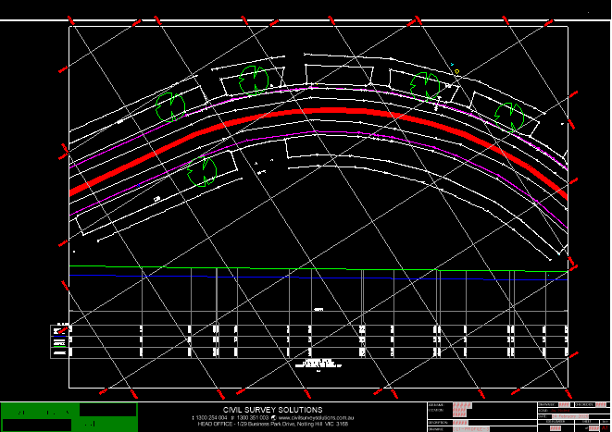
..................................................................................................................
Goto-layout

This is as it implies a Goto a layout, like a page goto in other software. Just type goto and enter layout as a number, World is layout 0, if you enter a large number it will go to the last layout.
..................................................................................................................
Hatch plines
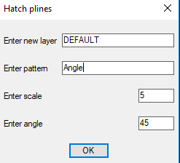
A common request hatch multiple plines in one go.

..................................................................................................................
Hop line

Draw a hop over where 2 lines etc cross. Two choices
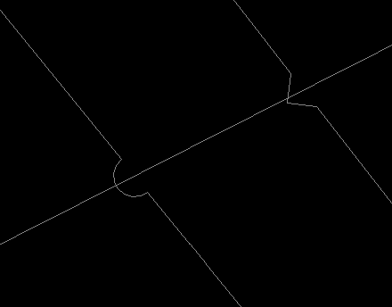
..................................................................................................................
Hordist
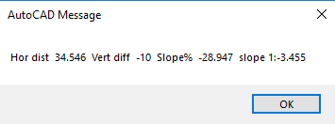
Pick two points and grades, horizontal and vertical distances shown.

..................................................................................................................
Insert image at text location

Matches a text label to a corresponding image of same name. It is useful for parts or a office layout.

..................................................................................................................
Lego block

A bit of fun draws a lego block.

..................................................................................................................
Line type dump

This draws a series of lines for each linetype with a label next to it. Useful to see all current available linetypes.
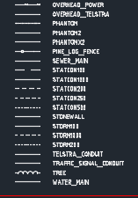

..................................................................................................................
Listbox-AH
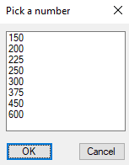
This library routine allows you to pick one item from a dialogue list of items.
It can be used in most lisp code with just a couple of lines of code, compared to a hard coded solution of around 50+ lines repeated every time you want to use a dcl.
..................................................................................................................

..................................................................................................................
LUDR-pline

Draw a pline by direction Up Down left or Right use upper or lowercase this version is a metric/decimal version, the option C closes or the option E ends the creation.

Version 2 depending on request will be an imperial version

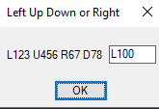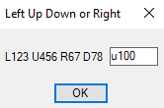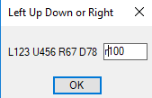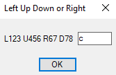


..................................................................................................................
MakeTable

This is example code of how to make an Autocad table used in conjunction with Lisp code.
..................................................................................................................
Make dxl XY

This allows you to make dcl with slide images selecting object by image useful for insert block or calling another function.
ma
..................................................................................................................

Make furniture table
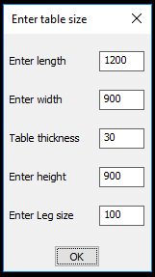
This is an example of how to make a simple object "household table" using multiple user input for sizes and producing a 3D object. Uses "Multi getvals" for inputs see below.

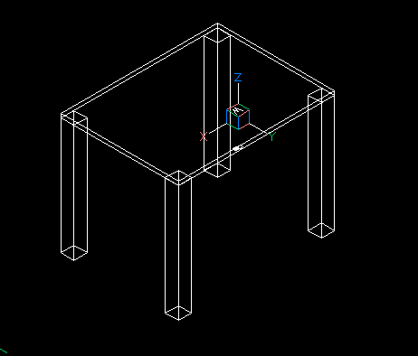
..................................................................................................................

Model title to layout

This makes layouts using title blocks from mspace this code is for metric and may need modification for imperial the code is hard coded for a A1 title block with a mview window of 800x500 ;the manual pick is to ensure layouts are created in correct order.
..................................................................................................................

Move window to zero
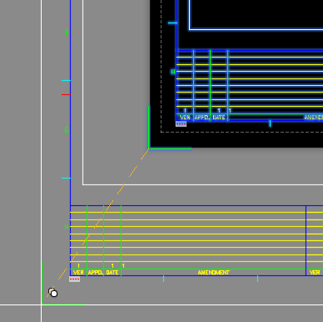
Moves all layouts to lower left 0,0 Has an offset ability for edge marker offsets, used to move Title blocks to a fixed location for auto plotting.

..................................................................................................................
Multiple pline offset with width and color
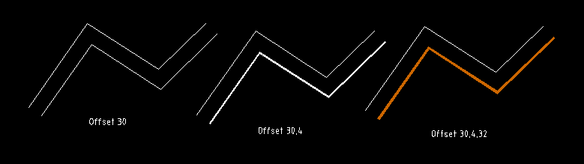

You have 3 choices enter a offset, enter a offset and width, or enter offset, width and color
30 30,4 30,4,32
..................................................................................................................
Multi Getvals
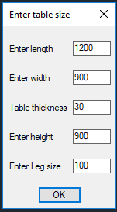
Multiple Getvals is a library routine that allows you to create as many lines of input as required (subject to Autocad limits) using a dialogue rather than the command line.

It can be used in most lisp code with just a couple of lines of code, compared to a hard coded solution of around 50+ lines repeated every time you want to use a dcl.

It only requires 2 lines of code in any lisp to use.

It will return a list of all the values you have entered. You can then assign the returned results to your variables.

There is examples in the top of the code how to use in your code.

For complete example look at "Make furniture table"

..................................................................................................................

Multi horizontal lines
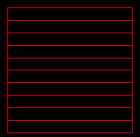
Allows you to create a box with ruled lines at a spacing.

..................................................................................................................
Multi line fillet
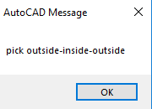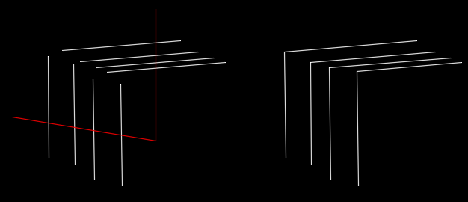
..................................................................................................................
Multi line offsets
Allows you to enter multiple offset values +ve and -ve offset is accepted as right and left offsets
..................................................................................................................
Multi Radio Buttons
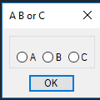
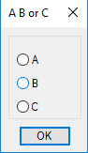
Multiple radio buttons is a library routine that allows you to create as many button selections as required (subject to Autocad limits) using a dialogue rather than the command line. It can be used as a replacement of INITGET.

It can be used for simple "Yes" or "No" type of question, or more complex "Left Right Up Down", .

It can be used in most lisp code with just a couple of lines of code, compared to a hard coded solution of around 50+ lines repeated every time you want to use radio button input.

It can be displayed horizontal or vertical. Picking a button will close the dialouge so no need to pick Ok.

It remembers the last picked so Ok can be chosen.

It only requires 3 lines of code in any lisp.

List of variables that can be chosen, check if already loaded else load, the picked button is returned in the ans variable , use V or H for dcl direction
..................................................................................................................
Multi Toggles

Allows for on / off choices, a Library function as many toggles as required.
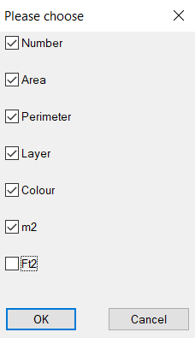
..................................................................................................................
Multi Getvals 2 col
As name implies 2 columns of input values
..................................................................................................................
Multi Radio 2col
As name implies 2 columns of radio buttons.
..................................................................................................................

Notch pline

Adds a notch at the corner of a pline.
..................................................................................................................

Objects to and from excel

This has to many variations, AlanH Consulting can discuss solutions to meet your needs.
..................................................................................................................
Perp to 2 pts
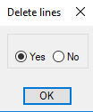
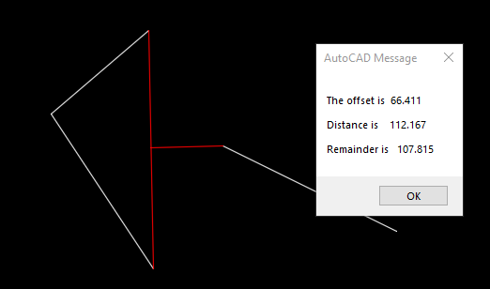
Perp to point draws a line perpendicular from a line made up of two points, so object does not need to exist. Useful when object is a polyline.

..................................................................................................................
Perpline to end of line
As the name implies you can draw a line and an additional line perpendicular to the last point, the options available for the new line are Left, Mid or Right.

The user is asked for the length of the "T" line. Once entered if repeated will be used as default value. It can be over ridden at any time.

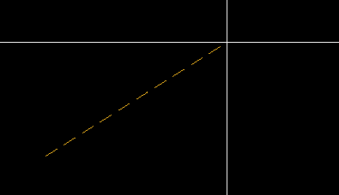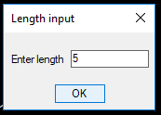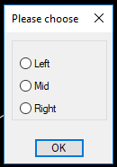
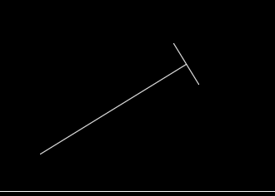
..................................................................................................................

Pipe ends
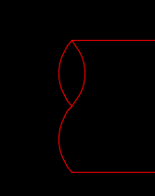
Draws the end of a circular pipe in a standard two arc end style by picking two end points.

..................................................................................................................
Pipe offsets


Pipe offset for different size pipes, replaces a single line with two lines at correct size of pipe equal to outside diameter.
..................................................................................................................
Pit
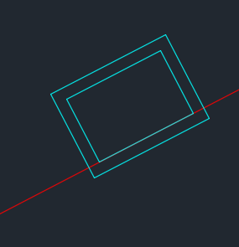
This draws a typical stormwater pit but aligns to 2 points when created.

..................................................................................................................
Pline co-ords2

Example of Creating a list of points for a Pline 3or dpoly or Line.
..................................................................................................................
Pline from list pts

Simple example method of making a pline from a list of points.
..................................................................................................................
Pline offset taper ends
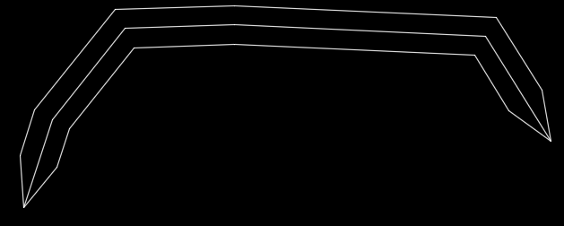
Take a single pline and offset it both side and have tapered ends.

..................................................................................................................
Pline co-ords
Simple way to create a list of pline co-ords
..................................................................................................................
Pline with tabs
This takes a pline and adds tabs of a user width useful for sheet metal work.
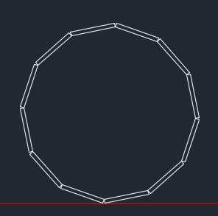
..................................................................................................................

Plot-titles-in-model

This will plot all title blocks in model space using a known Block, it uses the block location to plot by window. It requires some modification to suit user block, AlanH consulting can advise further
..................................................................................................................

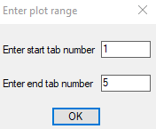
PlotA3B-WRange
PlotA3colrange
PlotA3Pdfrange
PlotA4black-white
PlotA4JPG
Plot tiff

Examples of plotting numerous layouts automatically, generally called from a menu for correct type and printer. Printer settings do need to be changed to match the end user printer names. Contact AlanH Consulting if you need assistance.

..................................................................................................................
Pramcross1
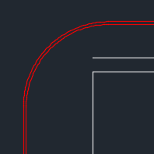
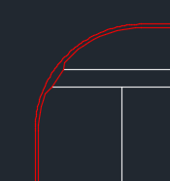
This draws a pram crossing in a typical kerb intersection, trims line work representing edge and back of kerb.

..................................................................................................................
Pt num bubble
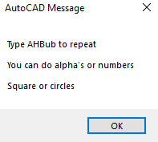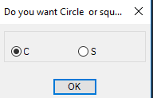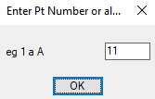

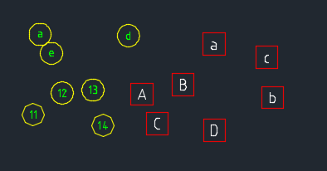
..................................................................................................................
Pt txt ht

A simple label the Z value of an Autocad point, see also Civ3D pt ht
..................................................................................................................
Rectang with holes

Create a rectang and add corner holes.
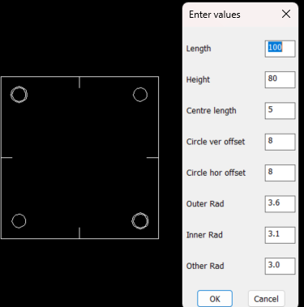
..................................................................................................................
Pline Rectang with chamfer corners
Draw a rectang and chamfer the corners can do 1 -4 corners.
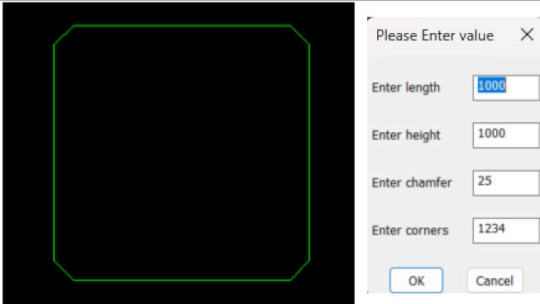
.................................................................................................................
Replace block attribute multi block names
Use this to pick multiple blocks and replace the 1st attribute
.................................................................................................................
Reset block to defaults

Allows the user to reset selected blocks to default attribute values

..................................................................................................................
Set paths
This is an example of how to set all the preferences when doing a new install or upgrade.It loads user menu's, user choice of toolbars that they would normally use. Need to run Tool bars 1st and save as say users name.

..................................................................................................................
SETEDIT SETLPNO SETOUT SETOUBOX SETOUTPT
These routines carry out various functions involving the setting out of field point, generally in civil construction, such as:

This allows the insertion of a block at a user chosen point and the entry of a point number (start number) it automatically increases the point number.

This routine exports the co-ordinates of the set out points created using the standard block pt_no (see setoutpt)

This allows the insertion of tabulated box of co-ordinates with desired text height. It reads a comma separated file from either the setout routine or from other software such as excel. (see setout)

Please contact AlanH Consulting to discuss your needs.
..................................................................................................................
Simple pline - pt offset

Pick a pline then pick a point gives a report of distance along pline and offset distance
..................................................................................................................
Slot
Draws a simple slot with round ends.

..................................................................................................................
SurfaceRL

Calculates the level of a picked point on a long section, drain or road cross section and updates a chosen text value. Useful where manual editing has been done and Rl needs to be labelled. Takes into account horizontal and vertical sc

..................................................................................................................
Swap attributes in block

This moves the attribute values in the block allowing rearranging.
..................................................................................................................
Text Add num to txt
Allows the addition or subtraction of an amount from existing text.
Either 1 at a time or multiple selection.

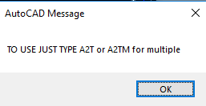

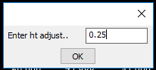
Select entities
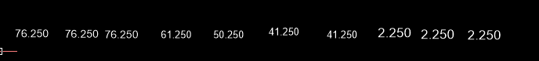
To exit just press "Esc" or just pick any where on drawing.
..................................................................................................................
Text Add prefix text
This routine adds a prefix text to the chosen text. Just enter the prefix and select text.
..................................................................................................................
Text Add suffix text
This routine adds a suffix text to the chosen text. Just enter the suffix and select text.
..................................................................................................................
Text Average
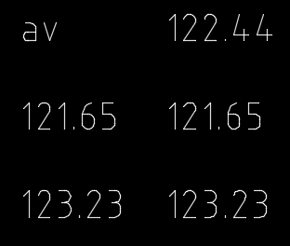
As the name implies pick text 1, pick text 2, pick text 3 and it is updated to the average of the two prior values.

..................................................................................................................
Text in polygon

An example of how to find text in multiple plines
..................................................................................................................
Text to voice

Example of you can have voice messages as part of your code.

"Please select again"
..................................................................................................................
Text180

Rotate selected text 180 update code
..................................................................................................................
Text2line

Rotates text to the same angle as a chosen line
..................................................................................................................
Text2xyz

Creates a 3D point based on numeric text values the point is located at the text insertion point. Useful for converting existing 2D plans to 3D where spot heights are shown as text.

..................................................................................................................
Textarea-csv
Pick text and it will return the enclosing poly boundary area, result can be written to a file.
..................................................................................................................
Textrot

Needs rewrite 2nd version of t155 reactor
..................................................................................................................
Txt1-txt2-txt3
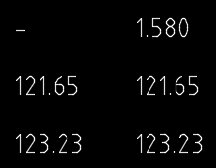
This allows you pick two text subtracting text1 from text2 then write answer to text3.

..................................................................................................................
Txt2lay

Searches for a key word in text and mtext and changes the layer.
..................................................................................................................
Trimupcross

A simple routine that repeats the Autocad commands to erase the extra right or left offset values and lines from cross sections that are created from some software.
..................................................................................................................
Uppcase

A simple convert selected text from lowercase to uppercase
..................................................................................................................
Update sheet num, Update sheet revs, Update order

These are used plus others to update title block attributes in layouts. Please contact AlanH Consulting to discuss your needs.
..................................................................................................................
Waffle slabs

Draws house waffle slabs within a pline shape.
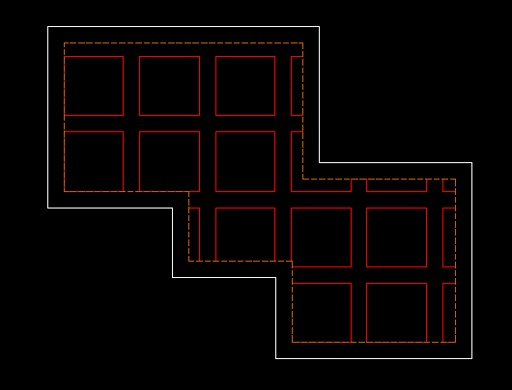
..................................................................................................................
Write-column-of-text

Writes columns of text to an excel spreadsheet can be used to create setout points for the surveyors as the excel spreadsheet data can be saved as a comma separated file for uploading.
..................................................................................................................
XFALL

Writes the text value 1 in x of an existing picked line or lines. Note will not work on polylines.
..................................................................................................................
XFALLPER

Writes the text value x% of an existing picked line or lines. Note will not work on polylines.
..................................................................................................................
Zigzag

An example of drawing a repeating pattern into a pline.
..................................................................................................................
Zoomextentsall
this is an example of zoom Extents in all layouts useful before a Save.
..................................................................................................................

THE END

This document is a work in progress as more functions are added, please check for updates.

