Multileader With Balloon Block/Labels
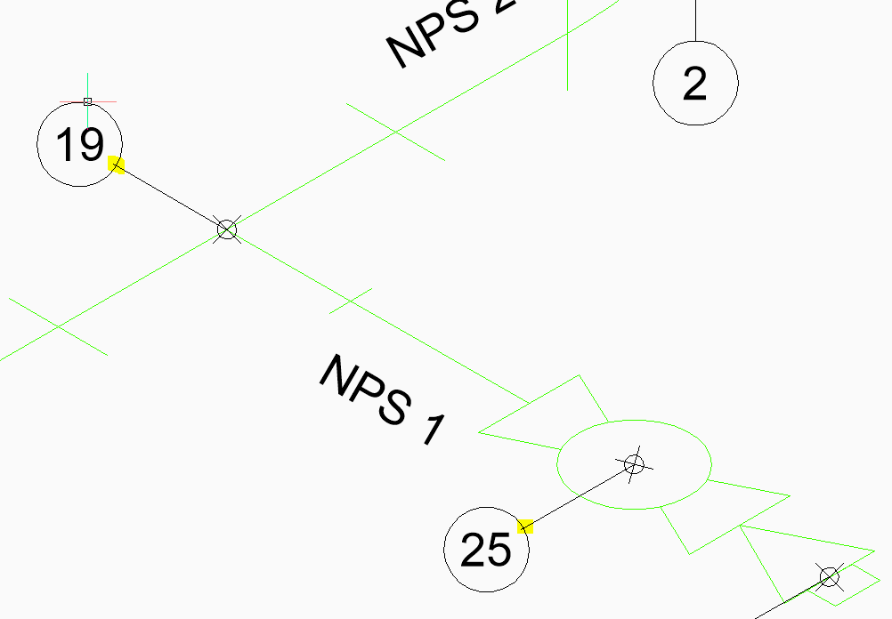
The balloon labels (created with the Multileader command and styled with a block and attribute at the end) in Paper Space have a leader line interfering with the balloon circle. These overlaps seem to be with the labels placed on an angle, in either direction as shown above but do not appear with the labels that are vertical or horizontal in orientation.
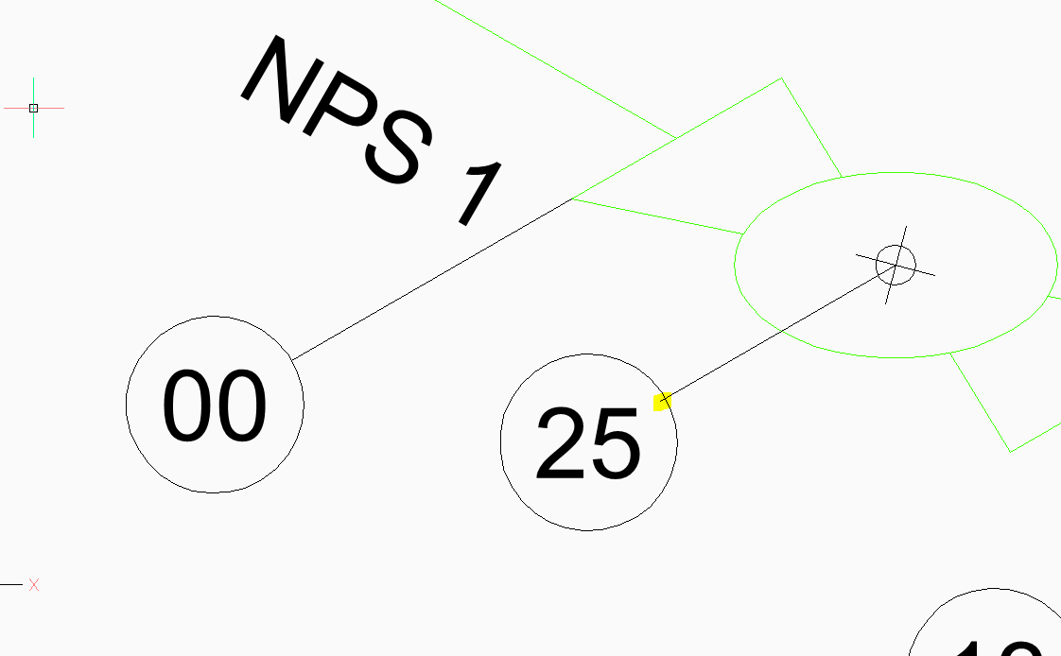
If a new label (using the Multileader command) is added to the drawing the overlap does not appear.
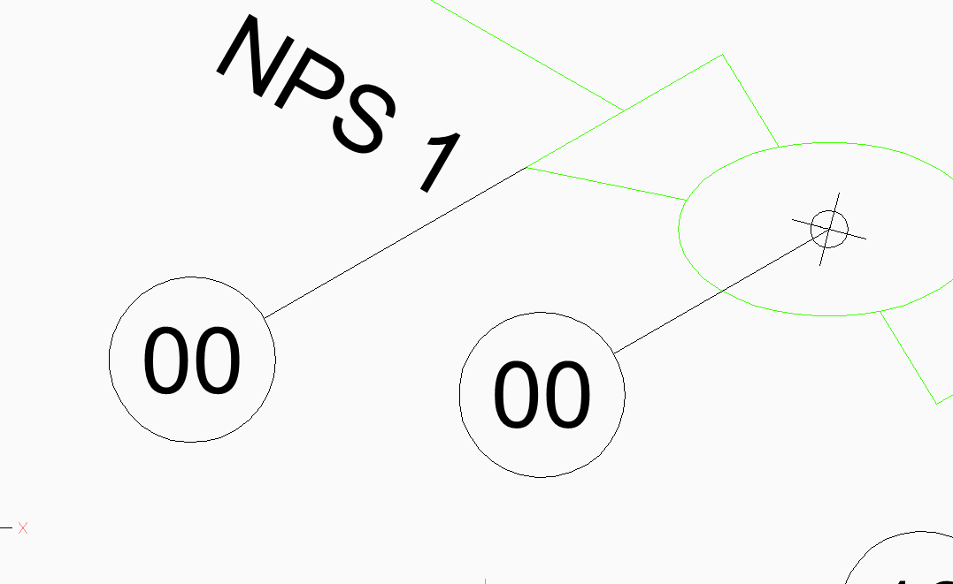
The Match Properties command will remove the overlap from the circle. This leads me to believe there is a System Variable setting that will change/remove the overlap but after some time spent reviewing the existing settings and new settings, I was not able to find it.

